General Nutrition Messages

The plant form of vitamin A that we find in orange coloured fruits and vegetables is known as retinol. Retinol supports healthy vision (this is probably for Year 9 upwards). Vitamin C can be found in citrus fruits, vegetables, peppers, green vegetables and potatoes. It is essential for a healthy, strong immune system, healing wounds on the skin and it also aids the absorption of iron. A great tip for pupils at breakfast time is to drink a small glass of fruit juice (150ml, freshly squeezed) with a bowl of iron-fortified cereal for instance. Vitamin C supports the absorption of iron in the body. Iron can be found in green leafy vegetables, red meat, dried fruit and fortified breakfast cereals (just some examples). Iron is particularly important for girls as their nutritional requirements for iron is higher. A deficiency in iron can lead to anaemia – symptoms are fatigue, tiredness, headaches and feeling faint.

Carbohydrates are the body’s preferred source of fuel so it is essential that we ensure we eat carbohydrates with every meal to support our body’s physically (walking, running, jumping, cycling). Wholegrain carbohydrates are higher in fibre which supports healthy digestion and they are also broken down more slowly in the body.

Milk and dairy foods are essential in children and young adults. They help support healthy bones and teeth. A diet high in calcium (particularly up to mid 20s) can help prevent osteoporosis so we should aim for 2-3 portions a day. What is a portion? – small yoghurt, 150ml skimmed milk, match box size of low fat cheese etc.

Meat, fish, eggs, beans and other non dairy sources of protein are essential to support the growth and repair of our muscles and body tissue. Lean sources of protein include lean red meat, poultry and fish. Fish is a low fat source of protein. Oily fish is high in omega 3 which supports brain and heart health. We should aim to eat one portion of oily fish including salmon, mackerel and tuna steak every week.

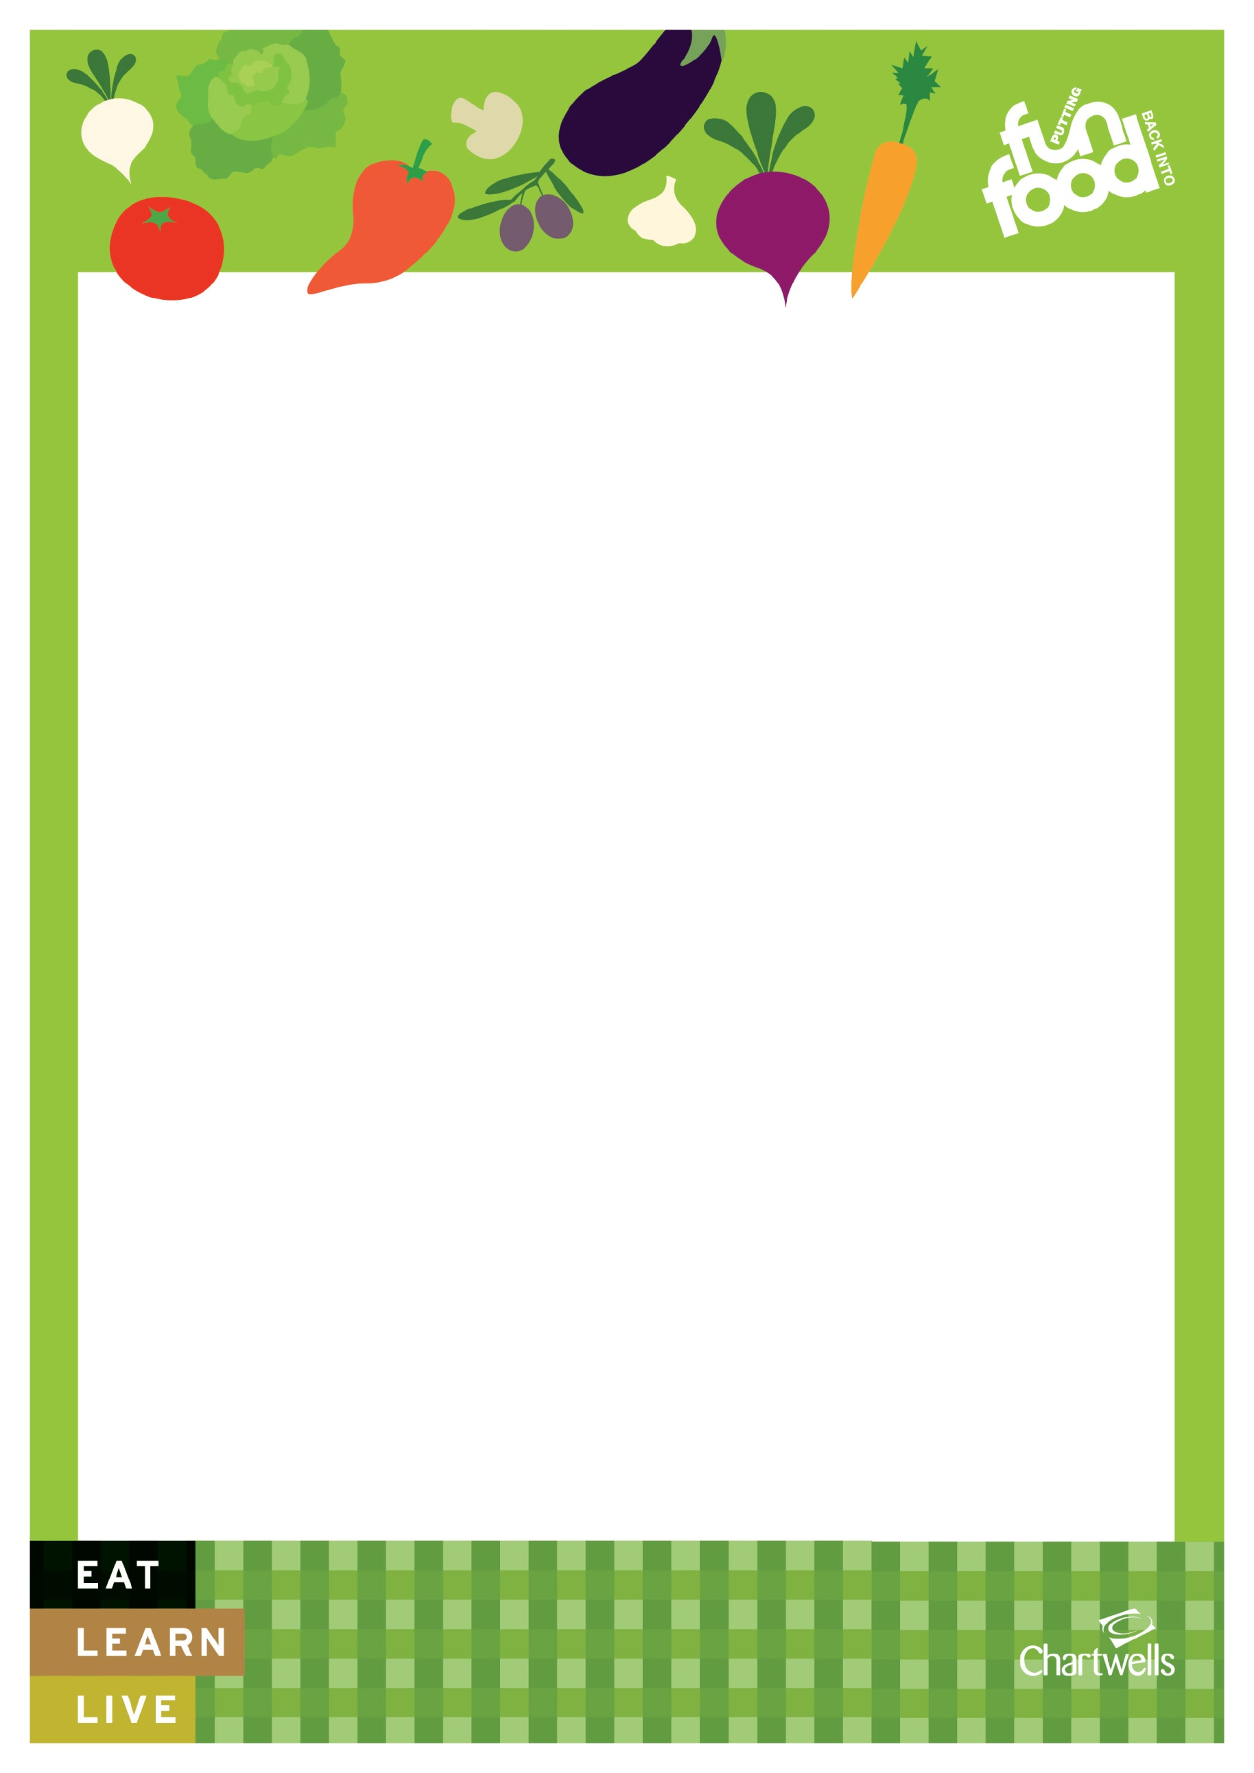
Food and drink high in fat and sugar is the smallest food group on the Eatwell Plate. These types of foods and drinks should be consumed in moderation as they are high in saturated fat, sugar and often salt. Too much sugar can lead to tooth decay and weight gain, too much saturated fat can lead to weight gain, cardio vascular diseases and/or high blood cholesterol. Too much salt can lead to high blood pressure and increased risk of stroke.

