Computing Policy
Date: | Spring 2020 | Review Date: | Spring 2021
Introduction

At St. Dominic’s Primary School we understand that ICT has evolved to become a part of everyday life and therefore we have a duty to provide a high-quality computing curriculum. The new National Curriculum has been developed to ensure children are taught the computational skills and digital literacy essential to their future both socially and economically. It is our aim to impart this knowledge so that they become competent, responsible and creative participants in the technology-rich world in which we live.

This policy will detail how we as a school will deliver the new computing curriculum requirements for KS1 and KS2. We aim to inspire our pupils with an array of technologies and a multifaceted skill set that they can apply at secondary school and beyond.

The national curriculum for computing aims to ensure that all pupils:
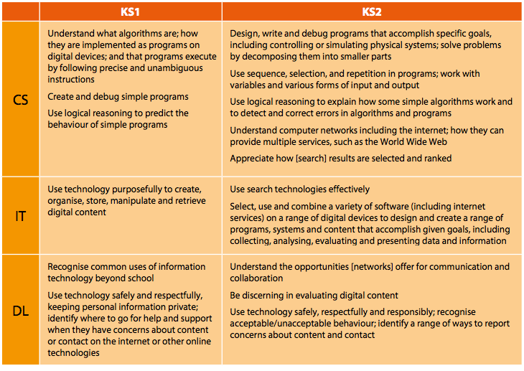

Contents

- Legal Framework
- Roles and Responsibilities
- Early Years Foundation Stage
- Key Stage 1
- Key stage 2
- Resources and Access
- Planning
- Assessment
- Equal Opportunities
- Staff Training
11. Monitoring and Evaluation
12. Useful Links
13. Glossary

1. Legal Framework

This policy is compliant with the DfE statutory guidelines:

‘Computing programmes of study Key Stages 1 and 2’

This policy also links with our:
- Computing and Online Policy
- E-Safety Policy
- Cyber-Bullying Policy

- Roles and Responsibilities

The Head Teacher will:
- Ensure that an inspiring computing curriculum is in place and that it is amended in light of new ICT and computing developments.
- Ensure all staff are teaching the primary curriculum compliant with the
‘Computing programmes of study Key Stages 1 and 2’
- Work collaboratively with the ICT coordinator for effective implementation of the Computing Policy and budget expenditure.

The ICT Coordinator will:

- Suggest how the budget is spent based on curriculum developments.
- Secure and maintain computing resources and advise other staff members how to best implement them in their teaching.
- Offer assistance to all staff members in their planning, teaching and assessment of the computing curriculum.
- Organise in-house training for staff members.
- Attend training forums to keep school practice up to date.
- Organise computing clubs for KS2.

Teachers will:

- Plan cross-curricular lessons with the help of the ICT coordinators to ensure the computing curriculum is being met.
- Equip children with the knowledge and skills within computing to build confidence and creativity.
- Develop and help children to understand how to use the Internet and computing technologies safely and responsibly.
- Meet individual needs and provide for a range of abilities including G&T, SEN and EAL.

- Early Years Foundation Stage

In their early development in technology and computing, children will be introduced to a number of play-based experiences in a variety of contexts. Children will be encouraged to make links to their own lives and the array of technologies and digital devices they encounter in the world around them. They will role-play and explore a broad range of computational devices such as recording devices, programmable robots and interactive whiteboards to develop communication skills and the basic fundamentals of the digital world.

- Key stage 1

Children in Key Stage 1 will be taught to:
- Understand what algorithms are and how they are implemented as programs on digital devices.
- Understand that programs execute by following a precise and unambiguous sequence of instructions.
- Create and debug simple programs.
- Predict the behaviour of simple programs.
- Create, organise, store, manipulate and retrieve digital content.
- Recognise common uses for computing and other aspects of ICT beyond school.
- Use technology and devices safely and respectfully being mindful of personal information and to identify where to go to for help and support when they have concerns online.

- Key Stage 2

- Design and write programs that accomplish specific goals, including controlling or simulating physical systems; solve problems by decomposing them into smaller parts.
- Use sequence, selection, and repetition in programs; work with variables and various forms of input and output; generate appropriate inputs and predicted outputs to test programs.
- Use logical reasoning to explain how a simple algorithm works and to detect and correct errors in algorithms and programs.
- Understand computer networks including the Internet; how they can provide multiple services, such as the World Wide Web; and the opportunities they offer for communication and collaboration.
- Describe how internet search engines find and store data; use search engines effectively; be discerning in evaluating digital content; respect individuals and intellectual property; use technology responsibly, securely and safely.
- Select, use and combine a variety of software (including internet services) on a range of digital devices to accomplish given goals, including collecting, analysing, evaluating and presenting data and information.

- Resources and Access

At St. Dominic’s we strive to continually maintain and audit our equipment to ensure it is fit for purpose, up-to-date and inspires pupils to develop in digital literacy. We have invested in resources that will help us to successfully deliver the national curriculum and provide stimulating lessons for all.

All equipment must be returned to its rightful place and any faults or incidents with equipment must be reported to the ICT coordinators, the support technician or the office manager as soon as possible. All classroom technology should be stored somewhere safe and regular maintenance should occur.

- Planning

The scheme of work we will be using was devised by the ICT subject leaders and evaluated by our ICT consultant from the Hackney Learning Trust to deliver the Computing National Curriculum. St Dominic’s has decided to adopt an embedded approach to the ICT programme of study, meaning computing can be taught in a meaningful context derived from other subject areas. Working through the curriculum in this way will provide a structure of progression and continuity. We will work on a half-termly grid and the teachers, with support from the ICT coordinators will decide the order in which the units are taught. The six aspects of focus will be Coding, Computer science, Networks and the Internet, Communication and collaboration, Creativity and Productivity.
Each scheme of work will include:
- Topic Title
- Curriculum Coverage
- Learning Objectives
- Outline of Activities
- Resources
- Cross-Curricular Links
- Assessment Opportunities

- Assessment

The assessment for learning techniques outlined in our Assessment Policy will be used to assess developments in the Computing National Curriculum.

Self-assessment, peer-assessment, open questioning, peer discussion, target setting and asking children what further developments they would like to make will be vital in assessing formatively and will instruct further teaching.

Summative assessment will help monitor a pupil’s progress half-termly with our criteria-based approach helping to build a portfolio of each child’s evidenced achievements. These portfolios will further instruct teachers in their planning and resourcing to help all children achieve their targets. The targets are set out below.
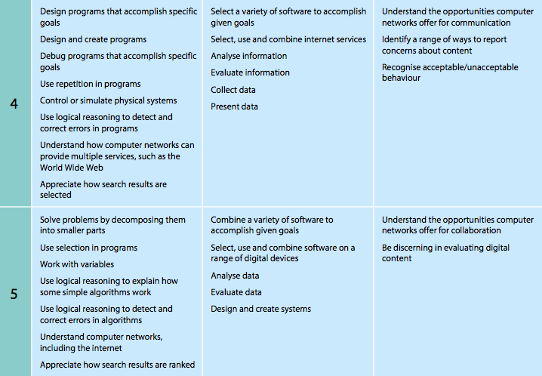
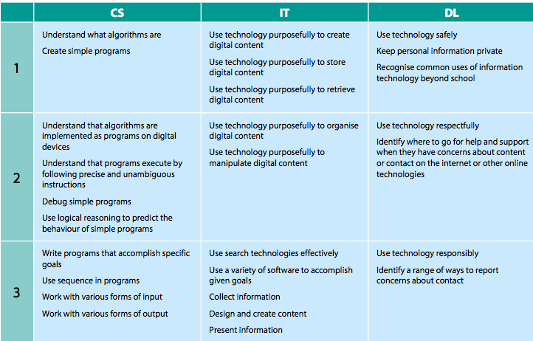

- Equal Opportunities

All children have access to the computing curriculum and the resources the school provides and all staff follows the equal opportunities policy. All children will be provided with the same learning opportunities and experiences whatever their race, social class, gender, culture disability or learning difficulties. Resources for children who are gifted and talented, have special needs or English as a foreign language will be provided with specialist support.

- Staff training

The computing coordinator will be responsible for the identification and delivery of staff training requirements. Staff training requirements will be met by:
- Auditing staff skills and confidence in the use of computers and ICT on an annual basis.
- Arranging top-up training for individual staff members as required.
- Ensuring all staff are up-to-date with E-Safety procedures with the help of the SENCO.

The computing coordinator will remain up-to-date with the latest developments in computing through subscriptions to relevant journals, attendance at relevant courses, etc, and will pass on any newly acquired knowledge/skills to staff members, where appropriate.

- Monitoring and Evaluation

At St. Dominic’s we understand that the world of technology is constantly advancing and new changes and applications are constantly evolving. Therefore we will review our policy on an annual basis and make any necessary changes.

The subject leaders are responsible for the quality of what is being taught and will continually evaluate what is being taught and learned by all teachers and pupils.

- Useful Links for Teachers

www.codeclub.org.uk - Provides detailed plans for extra-curricular activities.

http://csunplugged.org/ - Computer Science unplugged provide and excellent variety of resources for computer science.

www.computingatschool.org.uk - Computing at school has a large resource bank of
plans and activities.

www.code-it.co.uk - CAS Primary Master Teachers is a plan share website.

www.digitalschoolhouse.org.uk - Digital Schoolhouse provides plans.

http://scratched.media.mit.edu/ - There are excellent resources available for teaching with MIT’s Scratch programming toolkit, together with an online support community, on the ScratchEd site.

www.childnet.com - Safe, respectful and responsible use of technology ideas.

- Glossary

Algorithm – an unambiguous procedure or precise step-by-step guide to solve a problem or achieve a particular objective.

Computer networks – the computers and the connecting hardware (wifi access points, cables, fibres, switches and routers) that make it possible to transfer data using an agreed method (‘protocol’).

Control – using computers to move or otherwise change ‘physical’ systems. The computer can be hidden inside the system or connected to it.

Data – a structured set of numbers, representing digitised text, images, sound or video, which can be processed or transmitted by a computer.

Debug – to detect and correct the errors in a computer program.

Digital content – any media created, edited or viewed on a computer, such as text (including the hypertext of a web page), images, sound, video (including animation), or virtual environments, and combinations of these (i.e. multimedia).

Input – data provided to a computer system, such as via a keyboard, mouse, microphone, camera or physical sensors.

Output – the information produced by a computer system for its user, typically on a screen, through speakers or on a printer, but possibly though the control of motors in physical systems.

Program – a stored set of instructions encoded in a language understood by the computer that does some form of computation, processing input and/ or stored data to generate output.

Selection – a programming construct in which the instructions that are executed are determined by whether a particular condition is met.

Sequence – to place programming instructions in order, with each executed one after the other.

Simulation – using a computer to model the state and behaviour of real-world (or imaginary) systems, including physical and social systems; an integral part of most computer games.

Software – computer programs, including both application software (such as office programs, web browsers, media editors and games) and the computer operating system. The term also applies to ‘apps’ running on mobile devices and to web based services.

Variables – a way in which computer programs can store, retrieve or change simple data, such as a score, the time left, or the user’s name.

Signature of Chairman of Governing Body

Signature of Head Teacher

Review Date

