

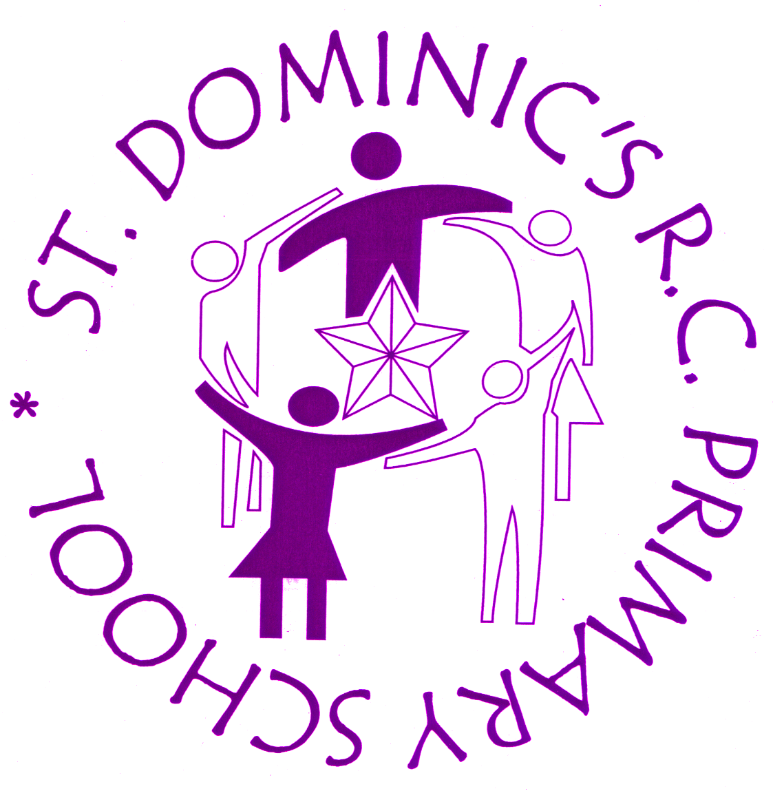





Written by: Nataliya Nayda
Approved by: Deirdre Finan
Last reviewed on: September 2022
Next review due by: September 2023

Contents
1. Aims 3
2. Legislation 3
3. Structure of the EYFS 3
4. Curriculum 4
5. Assessment 5
6. Working with parents 5
7. Safeguarding and welfare procedures 6
8. Behaviour monitoring procedures…………………………………………………………..6
9. Transitions…………………………………………………………………………………….7
10. Monitoring arrangements…………………………………………………………………..7

1. Aims
This policy aims to ensure:
- That children in EYFS of St. Dominic’s school access a broad and balanced curriculum that gives them the broad range of knowledge and skills needed for good progress through school and life
- Quality and consistency in teaching and learning so that every child makes good progress, and no child gets left behind
- A close working partnership between staff and parents and/or carers
- Every child is included and supported through equality of opportunity and anti-discriminatory practice

2. Legislation
This policy is based on requirements set out in the statutory framework for the Early Years Foundation Stage (EYFS) that applies from September 2021.
The EYFS is based around four principles:
A Unique Child
We recognise that every child is a competent learner who can be resilient, capable, confident and self-assured. We recognise that children develop in individual ways and at varying rates. Children’s attitudes and dispositions to learning are influenced by feedback from others; we use praise and encouragement as well as celebration and rewards to encourage and develop a positive attitude to learning.
Positive Relationships
We recognise that children learn to be strong and independent from secure relationships and aim to develop caring, respectful, and professional relationships with the children and their families.
Enabling Environments
We recognise that the environment plays a key role in supporting and extending the children’s development. Through observations we assess the children’s interests, stages of development and learning needs before planning challenging and achievable activities and experiences to extend their learning.
Learning and Development at Child’s pace
The Early Years Foundation Stage Unit is organised to allow children to explore and learn securely and safely. There are areas where the children can be active, be quiet and think independently and in partnerships. The unit is set up in learning areas where children can find and locate equipment and resources independently.

3. Structure of the EYFS
The Early Years Foundation Stage at St Dominic’s consists of one Nursery unit and one Reception unit.
There is one qualified teacher and one Early Years Practitioner in the Nursery unit.
St. Dominic’s Nursery is available for part-time (3 hours per day) and (full-time 6.5 hours per day) education for those children who are eligible for an Extended Entitlement. We offer an option of full time for a fee of £10 per day, which is calculated half-termly, for those children who are not eligible for an Extended Entitlement.
Reception class has one teacher and one Early Years Practitioner.
We encourage all staff to undertake training. We aim to ensure that the EYFS staff work as an effective, motivated, and dedicated team.
The Early Years will provide an environment that is happy, warm, secure, and stimulating. We aim to ensure that all children become confident, independent and enjoy exploring and learning. We aim to enable children to develop a strong sense of self, while also learning to play, negotiate and co-operate with others.

4. Curriculum
At St Dominic’s we aim to create a place where children can explore and meet new friends, be safe and adventurous. We value each child as unique individuals. We provide a wide and rich educational programme of learning.
Our early years’ settings follow the curriculum as outlined in the latest version of the EYFS statutory framework that applies from September 2021.
The EYFS framework includes 7 areas of learning and development that are equally important and inter-connected. However, 3 areas known as the prime areas are seen as particularly important for igniting curiosity and enthusiasm for learning, and for building children’s capacity to learn, form relationships and thrive.
The prime areas are:
• Communication and language
• Physical development
• Personal, social, and emotional development
The prime areas are strengthened and applied through 4 specific areas:
• Literacy
• Mathematics
• Understanding the world
• Expressive arts and design

4.1 Planning
Planning starts with observation – this is the key tool that enables appropriate and suitable planning that is challenging and appropriate for all children. At St. Dominic’s we plan activities and experiences for children that enable them to develop and learn effectively. In order to do this, staff working with the youngest children are expected to focus strongly on the 3 prime areas.
Staff also consider the individual needs, interests, and stage of development of each child in their care and use this information to plan a challenging and enjoyable experience. Where a child may have a special educational need or disability, staff consider whether specialist support is required, linking with relevant services from other agencies, where appropriate.
In planning and guiding children’s activities, staff reflect on the different ways that children learn and include these in their practice.

4.2 Teaching
Each area of learning and development is implemented through planned, purposeful play, and through a mix of adult-led and child-initiated activities. Staff respond to each child’s emerging needs and interests, guiding their development through warm, positive interaction.
Play is the way in which young children learn. Through play, in a secure environment, with effective adult support, children can:
- Explore, develop, and represent learning experiences that help them make sense of the world
- Enjoy learning, practise, and build up ideas, concepts and skills
- Learn how to control impulses and understand the need for rules
- Be alone, be alongside others or cooperate as they talk or rehearse their feelings
- Take risks and make mistakes
- Think creatively and imaginatively
- Communicate with others as they investigate or solve problems
- Express fears or relive anxious experiences in controlled and safe situations

Outdoor Play
The opportunity to play outside, throughout the year, in all different kinds of weather is as important as playing inside and is a statutory part of the EYFS - it is every child’s entitlement. Nearly everything that is provided inside can be provided outside and some of the best learning can only happen outside. For many children, the learning that happens outdoors is the most important.
To monitor the overall effectiveness of teaching and learning in the EYFS we use the Characteristics of Effective Learning tool
• playing and exploring – how the children investigate and experience things, and ‘have a go’
• active learning – how the children concentrate and keep on trying if they encounter difficulties, and enjoy achievements
• creating and thinking critically – how the children have and develop their own ideas, make links between ideas, and develop strategies for doing things.
As children grow older, and as their development allows, the balance gradually shifts towards more adult-led activities to help children prepare for more formal learning, ready for Year 1.

5. Assessment
At St. Dominic’s, ongoing assessment is an integral part of the learning and development processes. Staff observe pupils to identify their level of achievement, interests and learning styles. These observations are used to shape future planning. Staff also take into account observations shared by parents and/or carers.
Records we keep include:
- Profile files for each child with dated photographs and samples of artwork and mark-making
- Relevant observations
- Parent/carer comments
- Records of meetings regarding the child (with parents and/or other professionals)
- Samples and observations from home/ other settings the child attends
- Summary reports of progress and next steps and targets.
- Settling in reviews and initial information provided by the parent/carer
- On entry assessments
- Records are stored so that they are easily accessible to staff, children, and parents in the child’s classroom. All staff are sensitive to issues of confidentiality.
Within the first 6 weeks that a child starts Reception, staff will administer the Reception Baseline Assessment (RBA).
At the end of the EYFS, staff complete the EYFS profile for each child. Pupils are assessed against the 17 early learning goals, indicating whether they are:
• Meeting expected levels of development
• Not yet reaching expected levels (‘emerging’)
The profile reflects ongoing observations, and discussions with parents and/or carers. The results of the profile are shared with parents and/or carers for their child.
The profile is moderated internally (referring to the Development Matters guidance) and in partnership with other local schools, to ensure consistent assessment judgements. EYFS profile data is submitted to the local authority.

6. Working with parents
We work in partnership with parents and carers to meet the needs of the children and families, both individually and as a group.
Please note, it is a requirement for each child to be assigned a key person.
We recognise that children learn and develop well when there is a strong partnership between staff and parents and/or carers.
Parents and/or carers are kept up to date with their child’s progress and development. The progress check and EYFS profile helps to provide parents and/or carers with a well-rounded picture of their child’s knowledge, understanding and abilities.
Each child is assigned a key person who helps to ensure that their learning and care is tailored to meet their needs. The key person supports parents and/or carers in guiding their child’s development at home. The key person also helps families to engage with more specialist support, if appropriate.

7. Safeguarding and welfare procedures
We follow the safeguarding and welfare requirements detailed in Keeping Children Safe in Education 21 Guidance and we adhere to the school’s safeguarding policy.
Children’s safety and welfare is paramount. We create a safe and secure environment and provide a curriculum which teaches children how to be safe, make choices and assess risks. We have stringent policies, procedures, and documents in place to ensure children’s safety.
We promote the good health of the children in our care in numerous ways, including the provision of nutritious food, following set procedures when children become ill or have an accident.
Please see our separate policies and procedures on Health and Safety, Safeguarding and Child Protection, Computing and Online Safety, Food and Drink; Medical Needs, Educational Visits, Intimate Care, Pastoral care, Positive Handling, Uncollected Children and Vulnerable Children.
We are a Healthy School and our children under 5 receive free milk and all children have access to fresh water and free fruit from the Government scheme. Reception children are eligible for free school meals or can choose to bring in a healthy packed lunch.
Each foundation stage classroom has access to their own toileting facilities, and we teach the children the importance of hygiene, hand washing techniques and we plan cooking activities throughout the year to give children experiences of a range of healthy food.
We take all accidents seriously and always log and phone home immediately if a child has a bump to their head. We have cold compresses stored in the Nursery and Reception fridges.
We acknowledge that young children often have ‘accidents’ (i.e. wet themselves) and have stocks of spare clothes and change anyone who needs it. We ask parents to help keep our stocks of clothes high by returning anything their child has borrowed. Children are changed in the open area outside the toilets.

All large climbing equipment is checked by our site officer and fire alarms are held regularly in line with whole school policy. There is an annual external check of equipment. We follow whole school procedures for safeguarding and child protection.
Any child protection, safeguarding or other relevant concerns are discussed with the nominated Designated Safeguarding Lead (Andrew Armstrong) and Deputy Safeguarding Lead within the school (Deirdre Finan).

8. Behaviour monitoring procedures
The Early Years Behaviour Policy is part of the whole-school behaviour policy and the section specifically relating to Early Years reads as follows:
“The Stay on Green system is adapted for Early Years and builds upon good practice in this area. A visual chart is used to show some of the Stay on Green colours. The language of ‘green’ can be used with pupils and provides specific feedback for pupils as to what behaviour the school would like them to do more of, with the important focus being on positive feedback.”

9. Transitions
Transitions are carefully planned for, and time given to ensure continuity of learning. At any transition, we acknowledge the child’s needs and establish effective partnerships with those involved with the child and other settings, including nurseries and childminders.
Before they start at St. Dominic’s each child is invited to school to meet the head teacher, teachers and visit the classrooms in order make the transition to school as smooth as possible.
At the beginning of the school year new Nursery and Reception children are given staggered entry dates to ensure that they have the time to feel welcomed and to support them in exploring their new environment.
In the final term of Reception, the Year 1 teachers will meet with the Early Years staff and discuss each child's development against the Early Learning Goals in order to support a smooth transition to Year 1. This discussion helps the Year 1 teacher to plan an effective, responsive, and appropriate curriculum that will meet the needs of all children. Reception children visit Year 1 settings to meet their Year 1 teachers and familiarise themselves with the new setting.

10. Monitoring arrangements
This policy will be reviewed annually in September.
At every review, the policy will be shared with the governing board.

