Year 1 | Autumn 1 | Autumn 2 | Spring 1 | Spring 2 | Summer 1 | Summer 2
In class text and class book | The Bear in the Scary Night  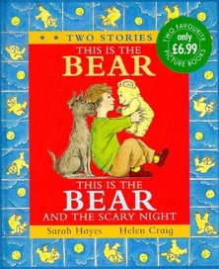 | Beegu  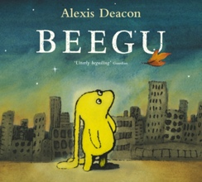 | Owl Babies  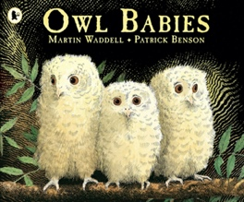 | Rainbow Fish  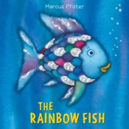 | The Flower  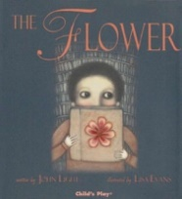 | Handa’s Surprise  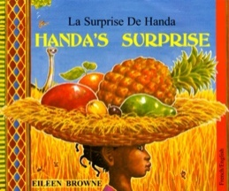
Second Class Text | Where’s my Teddy?  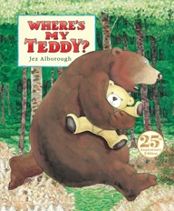 | Look Up  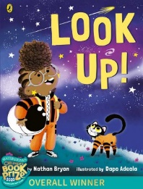 | Trees – Seasons come and go  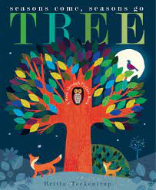 | The Illustrated Compendium of Amazing Animal Facts  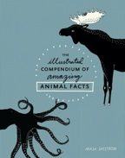 | Jack and the Beanstalk  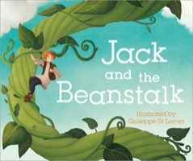 | Oi Frog  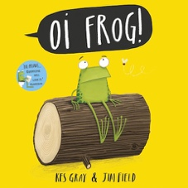
Wider Curriculum theme | Ourselves – Feelings and Senses | Space | Seasons | Animals | Plants | Around the World
Reading  (DR/DSR) In addition to retrieval, inference and word building. | - predict what might happen from details stated and implied. | - asking questions to improve understanding | - Answering Questions to improve comprehension | -Summarising to explain what happened in a story | -Sentence making and recognition – ordering text, matching text to pictures | -make connections to the wider world
SPAG  Vocabulary, Grammar, Punctuation | Punctuation – Capital letters and full stops | Plural –s- and plural –es- | Sentence construction – Simple noun phrases and expanded noun phrases | Joining sentences using ‘and’ | Using suffixes and prefixes | Different types of sentences
ORACY | Participate | Active listening | Build on ideas | Summarise | Recite | Active listening
Extended writing outcomes | Narrative (short story)  Character description  Sequencing  Retell beginning, middle and end | Narrative (short story)  Character description  Setting description  Sequencing  Retell beginning, middle and end | Report Writing  Report about Seasons  Descriptions about Seasons | Fantasy Stories  Character description  Setting description  Sequencing  Retell beginning, middle and | Report Writing  Report about animals  Descriptions about animals | Poetry  To write a poem with a repetitive refrain
PSHE links | Ourselves – Respecting one another and acknowledging feelings. | People from other places – how do we learn about them and make them feel welcome? | Keeping Safe | Positive Relationships | Looking after our planet | Living in the wider world.
MATHS | Number and Place Value  Number Bonds  Addition within 10  Subtraction | Addition  Subtraction  Ordinal Numbers  Numbers to 40  Numbers and words | Money  Fractions  Shape  Time  Data Handling | Addition/Subtraction  Capacity/Volume  Mass  Length | Number and Place Value  Addition  Subtraction | Addition  Subtraction  Multiplication  Division  Position and Turns
Science | Animals Including Humans  Name and locate human body parts including those related to sense  Understand that people change as they get older  Comparing and looking at similarities and differences  Understand that we need our senses to help us explore the world around us  Caring for pets  Home corner hospital | Use of Everyday Materials  Understand that objects need to be distinguished from their materials  Describe materials using scientific vocabulary  Understand that objects are made from materials with properties and begin to describe those properties  Identify and name a variety of everyday materials, including wood, plastic, glass, metal, water and rock | Seasonal Changes  Understand and describe the main changes across the seasons  Understand weather associated with the seasons  Understand how day length varies across the year | Animals Including Humans  Be able to identify and name different common animals including fish amphibians, reptiles, birds and mammals.  Be able to describe and compare the observable features of animals from a range of groups.  Recognise that animals can be grouped according to whether they are carnivores, herbivores and omnivores.  Know the basic needs of animals for survival. | Plants  Be able to name a variety of different plants (including deciduous and evergreen trees).  Understand and describe how plants are suited to different habitats.  Understand and describe the structure of plants including leaves, flowers (blossom), petals, fruit, roots, bulb, seed, trunk, branches and stem. | Plants and Everyday Materials and Animals  Extending previous coverage
RE | Beginning with God | From Advent to Christmas | Sacraments | From Lent to Easter | Easter to Pentecost | TBC
Computing | Staying Safe Online – How can the Bear stay safe online when trying to find his/her way home?  Bee Bot Algorithms - Can you help the bear find his way home using the bee bots?  Piccollage – use the app to show how the bear is feeling at different parts of the story  Algorithms - Can you give teddy instructions to get home?  Piccolage – Pictures of my insides/labelling myself | Piccolage – Use this apps to make a graph of Beegu’s Feelings at different points in the story  Balloon Stickies – Use this app to show what Beegu is saying. Translate the Alien text!  Quiver – Create Beegu a Planet  Sketches – Design a rocket ship  Kapow – Rocket to the Moon | Digital imagery – capturing the season  Digital Collage – create a collage for the seasons  Green Screen – create a weather report  Kapow - Staying Safe Online  Chatterpix and Piccolage – Making fact files of animal seasonal habits | Data handling- Data handling types of animals/our pets  Book Creator - Pet care brochure  Sketches – Create an imaginary pet  Chatterpix – What would your pet say if it could talk?  Piccolage – Design a pet care poster  See Miss Slingsby’s Animals Unit (15 Lessons) | Stop-motion – Show the step by step process of our plants as they grow  Camera Apps – Children to take pictures of the plants they discover on garden walks  Camera – Use the edit function to label plants they discovered, children can put shapes around them, arrows, text… | See Miss Slingsby’s Handa’s Surprise Computing Unit (15 Lessons)
PE | GAMES  Large balls skills and games  DANCE  -Streamers  -Conkers  -Playing with a ball | GAMES  Focus on medium size balls  Gymnastics  Flight, bouncing, jumping and landing. | GAMES  Focus on using hoops and quoits  Gymnastics  Points and patches | GAMES  Focus on using bats, ropes and small balls  DANCE  Animal dances | GAMES  Jumping, running and rolling  DANCE  Jack and the beanstalk  Moving and growing | GAMES  Athletics  Gymnastics  Wide, Narrowed and Curled
History or Geography | Changes Within Living Memory  When I was a baby  When my parents were babies  Now I am 5 or 6  How I have changed since I was born  How my local area has changed since I was born  Old/New Bears | History of space/moon landings  Meteor history /locations  Famous astronauts  Solar system | Seasonal and Climate changes around the World  Seasonal comparisons with other countries  Famous weather people | Where do animals live?  David Attenborough – Who is he? What work does he do with animals? Why is he famous? | Famous horticulturists  Tropical plants  Domestic plants  English Farmland vs African/South American Farmland | Fruit and animals around the world  Comparing maps and terrain  Famous Kenyans  Famous Poets  Oceans of the world
DT | Make Skeleton, Make Puppet, Design and make an outfit for your bear, Rocket making |  | Easter themed activities – making baskets, eggs, cards, Under the sea models |  | Design a rain catcher, Use recycled material to make a water can, Can seeds grow through different materials? Tights, Socks etc
Art | Self Portrait, Finger Painting, Hand Painting, Stars/planets pictures |  | Under the sea models, Animal pictures, Nature pictures/paintings, Paper Mache animals |  | Van Gogh, Observational drawings, Collage Daffodils, Colour mixing with paints
Music | Routine Songs  Put Your Coat On  Goodbye  Manners  Five Senses  Head, Shoulders…  Dem Bones  Listening  Lining Up Song  Sharing  Friendship  Feelings  Belonging  My Body’s No Body’s but Mine | Zoom zoom we’re going to the moon  We are the planets  Time to shine  Countdown to blast-off  Songs about Materials  Barnaby bears magnets | Songs about seasons  Singing in the rain  30 days has September  This little light of mine  BBC – Summertime  When the cold wind blows | Animal songs  Disney animal songs  Five little ducks  Pete the cat | The needs of a plant  Soil  It needs five things  How does a plant grow?  The plant parts song | Afro beats  Cultural songs - Kenya and Britain  Songs famous in Africa and Europe
Displays | Literacy – Bear in the Scary Night  Numeracy – Number bonds and place value  Science – Ourselves  Topic – Ourselves  RE – Beginning with God | Literacy – Beegu  Numeracy – Multiplication / division  Science – Materials  Topic – Space  RE – From Advent to Christmas | Literacy - Trees – Seasons come and go  Numeracy – Time/Fractions/Shape  Science – Seasons  Topic – The weather  RE - TBC | Literacy -Rainbow Fish/Gruffalo  Numeracy – Measure  Science – Animals  Topic – animals and Habitats  RE – Lent to Easter | Literacy -Jack and the Beanstalk  Numeracy – Addition/Subtraction  Science – plants  Topic – Looking after the environment  RE – Easter to Pentecost | Literacy – Handa’s Surprise  Numeracy – Mul / div and turns  Science – Working wall  Topic – Geographical comparison  RE - TBC
Possible Trips  Visits | Pizza Express?  Science Museum 13th October  Epping Forest Stone Age Survival | London Street Surgery Visit- Junk Modelling? | Perform for all workshop on seasonal changes?  Can we visit a weather station/channel? | Animal visit  Hackney Farm  Aquarium | Kew Gardens  Park for plant hunt  Epping Forest – Plant hunt | Park  Big end of year trip – Chessington? Seaside? Shrek’s Adventure?

