Year 6 | Autumn 1 | Autumn 2 | Spring 1 | Spring 2 | Summer 1 | Summer 2
In class text | Traditional Tales, Folk and Fables  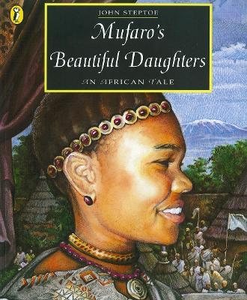  Mufaro’s Beautiful Daughters – John Steptoe | Stories with Related Themes  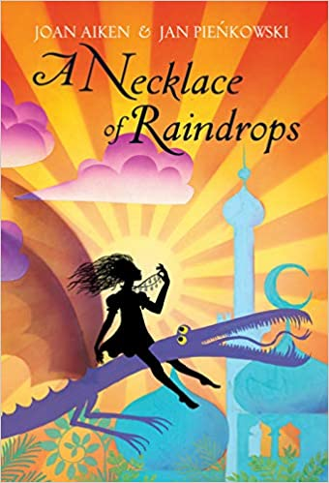  Necklaces of a raindrop – Joan Aiken | Non-Chronological Report  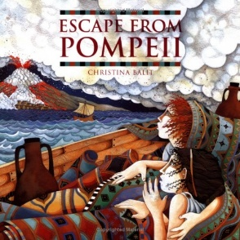  Escape from Pompeii – Christina Balit | Letters written for a range of purposes  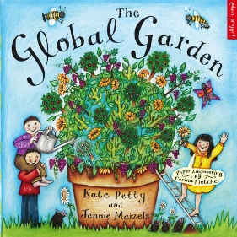  The Global Garden – Katy Petty & Jennie Maizels | Stories by same author - Roald Dahl  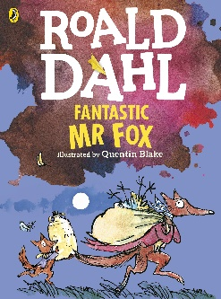  Fantastic Mr Fox – Roald Dahl | Adventure and Mystery Stories  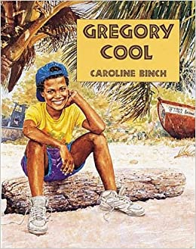  Gregory Cool – Caroline Binch
Class book | The Baker’s Daughters | The Baker’s Cat + The Patchwork Quilt | Roman Diary: The Journal of Iliona | The Night Gardener | The Twits | Fatima the Spinner and the Tent + The Julian Stories
Wider Curriculum theme | Traditional Tales, Folk and Fables | Stories with Related Themes | Romans | Plants | Stories by the Same Author | European countries
Reading  (DR/DSR) In addition to retrieval, inference and word building. | Introduce pupils to a new reading focus each week to ensure a smooth transition from DSR to DR and sufficient expose to all reading strategies to develop familiarity. | Prediction  Clarifying | Asking Questions  Clarifying  Making connections | Prediction  Summarising | Summarise  Evaluate | Asking Questions  Making connections  Evaluating
SPAG  Vocabulary, Grammar, Punctuation | Punctuation – capital letters and full stops.  Nouns, verbs and Adjectives. | Present and past tense  Expanded noun phrases  Direct speech | Formal language, 3rd person, factual information | Formal language, formulating writing for a range of purposes | Subordinate and main clause  Apostrophes – possessive and contracted. | Adverbials  Paragraphs
ORACY | Participate | Active listening | Build on ideas | Summarise | Recite | Clarify and Debate
Extended writing outcomes | Character description  Recount  Narrative (short story) | Letter writing – write in the role of a character  Narrative (short) | Non-Chronological Report Writing  Recount | Report writing  Leaflet  Diary entry | Newspaper report  Balanced argument | Character profile  Extending writing  Alternative ending
PSHE links  RHE | Building relationships, Anti-bullying, environment COP26. | Feelings and emotions | Environment: How can we look after our planet? | Families and close positive relationships  PSHE Programme of Study  R1, R8 and R9  Friends, Families and others (Module 2) | ‘Ourselves, growing and changing’  How am I different to others?  H21 – H24  My relationships with others  (Module 2) Assessment | Healthy lifestyle  ‘Health and Wellbeing’  H1 – H10  Module 2 - Unit 3 ‘Keeping Safe’  Drugs, alcohol and tobacco
MATHS | Number and place value | Four operations | Roman numerals + word problem solving | Shapes and angles  Symmetry  Geometry  Measurement | Area and Perimeter  Fractions  Decimals | Statistics  Time  Money
Science | Light and Shadows | Forces and Magnets | No science topic focus this term. Science will be incorporated using numeracy problem solving questions. | Plants | Rocks and Soil | Animals Including Humans
RE | Beginning with God | Advent to Christmas | Being a Sacramental person | From Lent to Easter | From Easter to Pentecost | A Godly Life
Computing | Using iPads to access TTRS  Research topics | Online Safety | Email – Purple Mash | Become a coder – Scratch  Sequences, loops and debugging. | Create a movie using iMovie | Produce and broadcast a news report (green screen).
PE | Handball  Fitness  Swimming | Hockey  Swimming | Tag Rugby  Swimming | Cricket  Swimming | Rounders  Swimming | Athletics  Swimming
History or Geography | History: Stone Age | History: Local History and Black History | Geography: Compare and Identify human and physical features of two places – UK and Naples.  Create a Roman map using a key to construct basic symbols for features.  Use simple compass points – N, E, S, W.  History: Roman Empire and ‘Romanisation’ of Britain.  Explore the impact of technology, culture and beliefs  The Roman Empire: What was it like in Roman Britain? What were Roman houses like?  What was a Roman family like? What technology did the Romans bring? | Geography – How do different climates affect harvest and plant growth? | Geography: Volcanoes, Earthquakes and Tsunamis | Geography: European Countries
Art or Design | Cave Art  Theatre puppet show  Designing stone age homes and clothing | Design and make a pulley | Design a Roman Chariot or Aqueduct.  Mosaic design for a kitchen floor | Planting seeds  Create a self-watering plant | Creating Fossils | Construction a life size human skeleton.
Music | African musicp | Music and instruments from around the world | Roman instrumentation and music themes of these times (performance).

