Year 4 | Autumn 1 | Autumn 2 | Spring 1 | Spring 2 | Summer 1 | Summer 2
In class text | Egyptian Cinderella  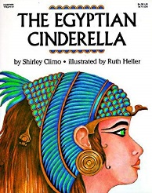 | Paddington – Michael Bond  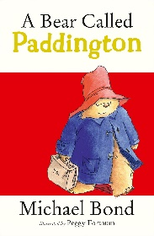 | The Iron Man – Ted Hughes  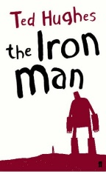 | 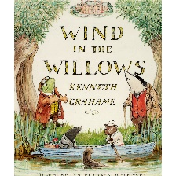  Wind in the Willows – Kenneth Graheme | 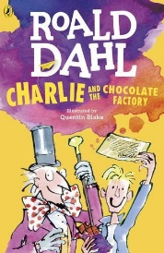  Charlie and The Chocolate Factory – Roald Dahl | Bill’s New Frock – Anne Fine  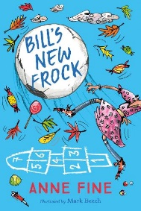  Poetry
Class book
Wider Curriculum theme | History - Ancient Egypt  (Earliest civilisations) | History – A non-European Society  Science – Animals incl Humans (Teeth, Digestive system) | Science – Electricity (construct simple circuits etc)  Geography –Place and Location knowledge | Geography – Location knowledge, Skills and fieldwork  Geography – Towns, cities and villages.  Build our own city. | History -The History of Chocolate  Geography – The journey of Cocoa | Identity and diversity  History and Geography – Our family tree
Reading  (DR/DSR) In addition to retrieval, inference and word building. | Introduce pupils to a new reading focus each week.  Predict | Predict  True or False  Summarise | Predict  Summarise  Making Connections  Ordering | Predict  Making Connections  Clarify  Inference | Predict  Making Connections  Clarify  Inference  Evaluate | Predict  Making Connections  Clarify  Inference  Evaluate
SPAG  Vocabulary, Grammar, Punctuation | Adjectives. Proper and Common Nouns, Verbs, Capital letters and Full stops. | Statements, Questions, Exclamations and Commands  Punctuation – Bullet points. | Speech Marks  Adverbs  Fronted adverbials | Subordinate and main clauses.  Apostrophes – Possessive and contractions. | Types of nouns – nouns, proper and common and possessive pronouns.  Plurals. | Speech marks.  Paragraphs.  Revision
ORACY | Talk Partners  Drama workshop | Presentation on a European country. | Class debate. | Talk Partners  Playscript - drama | Class debate.  Dragon’s den presentation. | Perform poetry.
Extended writing outcomes | Narrative writing – alternative ending  Non-Chronological Report | Descriptive writing  Postcard / Letter writing | Persuasive writing  Newspaper Report  Individual debate on robots. | Playscript  Diary entry | Newspaper article  Class Debate – Is Willy Wonka a good person? | Debate – Are boys and girls treated differently?  Narrative
PSHE links  RHE/ Ten Ten | How do we treat each other with respect? (Looking out how Egyptian Cinderella was treated)  Anti-Bullying | What strengths, skills and interests do we have? | How can we manage our feelings?  The importance of expressing feelings and how they can be  expressed in different ways  How to respond proportionately to, and manage, feelings in different circumstances  SEAL – Relationships  Getting on and  falling out | How will we grow and change?  Health and Wellbeing  ‘Ourselves, Growing and changing’  H25 – H29  ‘Created to love others’  Module 2  Story session – Jesus my friend | How can our choices make a difference?to others and the  environment?  “Is Willy Wonka a good person?” – Can a person be all good / all bad.  “Are the Oompa Loompas treated fairly?”  Module 3: Created to Live in Community with Others Unit 2: Big, Wide World | Relationships  “Are boys and girls treated differently?”  Family tree – What are families like?  How can we manage risk in different places?
MATHS | Place value, types of numbers (roman numerals, negative numbers) | The four operations, are and perimeter | Fractions and decimals and measurement | Money, Co-ordinates and data handling | Shape Angles and Time | Time and Revision
Science | Animals and their habitats | Digestive System and teeth | Electricity  Construct a simple series electrical circuit, identify and name basic parts  Recognise that a switch opens and closes a simple circuit  Associate metals with being good conductors | Sound | Changing states | The Water Cycle
RE | Beginning with the Church | From Advent to Christmas | Sacramental People | From Lent to Easter
Computing | We are Time Travellers:  -Film and photography  -Editing  -Digital footprint  -Publishing | We are animators:  -Planning  -Modelling  -Animation  -Editing | Scratch:  Adding and programming sprites  -Changing backgrounds. | Website design:  -Develop research, word processing and collaborative working skills.  -Change layouts | We are chocolate opinion pollsters:  -online surveys  -Analyse results  -Publish findings  -Email | Scratch:  -Variables  -Consumes  -Constraints  -Broadcasting  -Robots
PE
History or Geography | History – Ancient Egypt | Geography - Exploration | Geography – Villages and Cities  Identify human and physical topographical features : hills, mountains. coasts and rivers  Locate countries using a world map, globe and atlas | Geography – The UK  Villages, towns and cities continued. | History – The History of Chocolate  Geography – Journey of Cocoa | History – Where do we come from?
Art or Design | Write in Hieroglyphics.  Design and make Ancient Egyptian jewellery. | Create a treasure map.  Make an exploration mosaic. | Design and build a build a robot | Design and build a 3D city. | Bake chocolate cake.  Design and make our own chocolate product. | Create our own identity art.

