Year 6 | Autumn 1 | Autumn 2 | Spring 1 | Spring 2 | Summer 1 | Summer 2
In class text | “Viking Boy” Tony Bradman  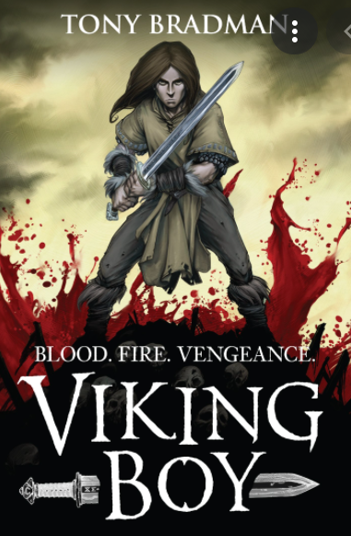 | 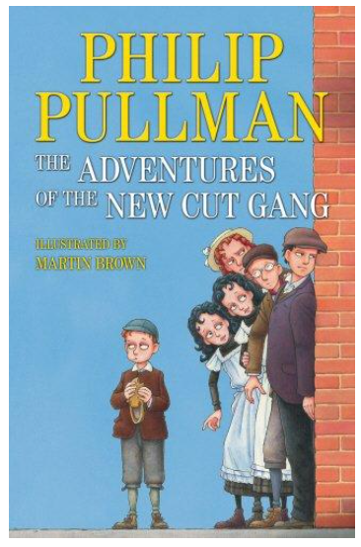  The Adventures of the New Cut Gang - Pullman | 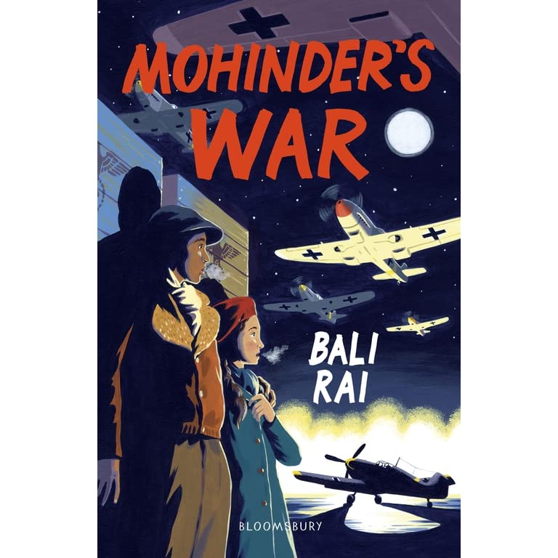  Mohinder’s War - Bali Rai | 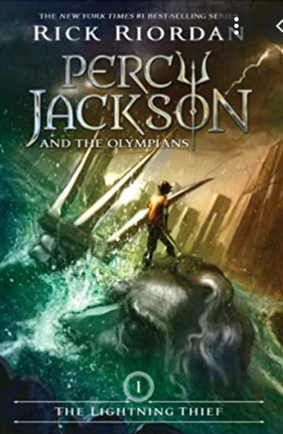  The Lightning Thief - Percy Jackson | I and I  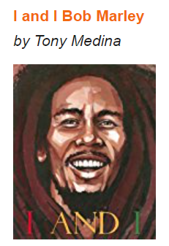  Bob Marley (poetry) | 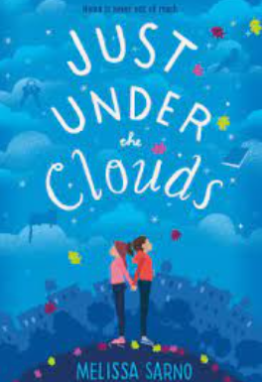  Just under the clouds - Melissa Sarno
Class book | The 50 Good Guys | The London Eye Mystery - Siobhan Dowd | Carrie’s War - Nina Bawden | Who let the Gods out Maz Evans | Rhythm and Poetry - Karla Nova | Just like me
Wider Curriculum theme | Vikings | Victorians  Victorian Christmas | WW2 | Ancient Greece | “Roots, Rhythms and Records” | Kidulthood to Adulthood
Reading  (DR/DSR) In addition to retrieval, inference and word building. | - predict what might happen from details stated and implied. | - asking questions to improve understanding | - Evaluate author’s purpose | -make connections within books, and to other texts | -make connections with self | -make connections to the wider world
SPAG  Vocabulary, Grammar, Punctuation | Punctuation - semi- colons/dashes/brackets | Word classes | Sentence construction | Tense  Past perfect / past progressive | Formal/Informal  language | passive/active voice
ORACY | Participate | Active listening | Build on ideas | Summarise | Recite | Clarify
Extended writing outcomes | Newspaper report  Letter from the front  Setting description | Narrative (short story)  Diary entry  Recount | Non-Chronological report  Character description  Persuasive argument | Narrative writing - writing own myth  Travel Brochure  Newspaper report | Biography  Poetry  Non-Chronological report | Balanced argument  Letter to myself  Job advertisement
PSHE links | Loyalty. Would you be loyal at all costs? | Friendship: How important is friendship and how do we become a good friend? | Difference: How do we respect the differences of others? | Resilience: Is there a difference between standing up for yourself and fighting? | Qualities/Role model/Values Why do we admire some qualities more than others? | Gratitude: What are you grateful for?
MATHS | Number, four operations, place value | Fractions, Decimals, Percentages, Ratio, | Handling Data, Geometry | Translation, Rotation, Transformation, Numerals | Word Problems, Algebra, Inverse | Application, Reasoning and CPA
Science | Animals Including Humans | Electricity | Living Things and Their Habitats | Inheritance and Evolution | Forces | Light
RE | Beginning with God | Advent to Christmas | Being a Sacramental People | From Lent to Easter | From Easter to Pentecost | A Godly Life
Computing | Big Data 1 | Big Data 2 | Bletchley Park | Intro to Python | Python | Skills Showcase
PE | Gymnastics | Invasion Games (football, netball, basketball, etc.) | Racket and Club Sports (rounders, hockey, tennis, etc.) | Dance | OAA | Athletics
History or Geography | Geography:  * Answer questions by using a map about Vikings  History:  * Key events from Britain’s past (Viking invasions and kingdoms)  * Historical events from times studied (Lindisfarne raid) | Geography:  * Describe how some places are similar and dissimilar in relation to their human and physical features (Victorian vs. modern East London)  History:  * Place historical events on a timeline (Victorian Era)  * Summarise how Britain has had a major global influence (British Empire) | Geography:  * Use ordnance survey symbols and 6 figure grid references (plotting enemy lines during a WW2 battle)  History:  * Identify and explain propaganda used during WW2 | Geography:  * Explain how time zones work and calculate time differences around the world (ancient Greece and beyond)  History:  * How has Britain learnt from other countries and civilisations (Democracy, Olympics, etc.)  * Identify and explain differences, similarities and changes between different periods of history (throughout time) | Geography:  * Use maps, aerial photographs, plans and e-resources to describe what a locality might be like (create a tourism pamphlet for Jamaica)  History:  * Identify and explain how history has been influenced by music and popular culture | Geography:  * Plan a world exploration  * Identify and name the Tropics of Cancer and Capricorn as well as the Arctic and Antarctic circles  * Name the largest desert in the world and locate desert regions in an atlas  History:  * Reflect on how my past will influence my future
Art or Design | Art:  * Use a range of art and e-resources to create my own longboat.  Design:  * Explain why hygiene is important when working with food | Art:  * Use a range of e-resources to create art to create a circus poster  Design:  * Design a circus poster inspired by Pablo Fanque  * Design our very own roundel (inspired by our tour of East London) | Art:  * Explain the style of my work and how it has been influenced by a famous artist to create a propaganda poster  * Over print to create different patterns to create a propaganda poster  Design:  * Evaluate my product against clear criteria  * Follow and refine my plans to design and create a bomb shelter | Art:  * Explain why I have used different tools to create Greek pots  * Explain why I have chosen specific techniques to create Greek pots  Design:  * Show that I consider culture and society in my plans and designs to design an amphitheatre | Art:  * Use feedback to make amendments and improvements to make a blanket  Design:  * Work within a budget to create a blanket inspired by Roots. Rhythms and Records | Art:  * To over print to create a world flag (by layering existing flags)  Design:  * Design and create our own wall art in the garden

