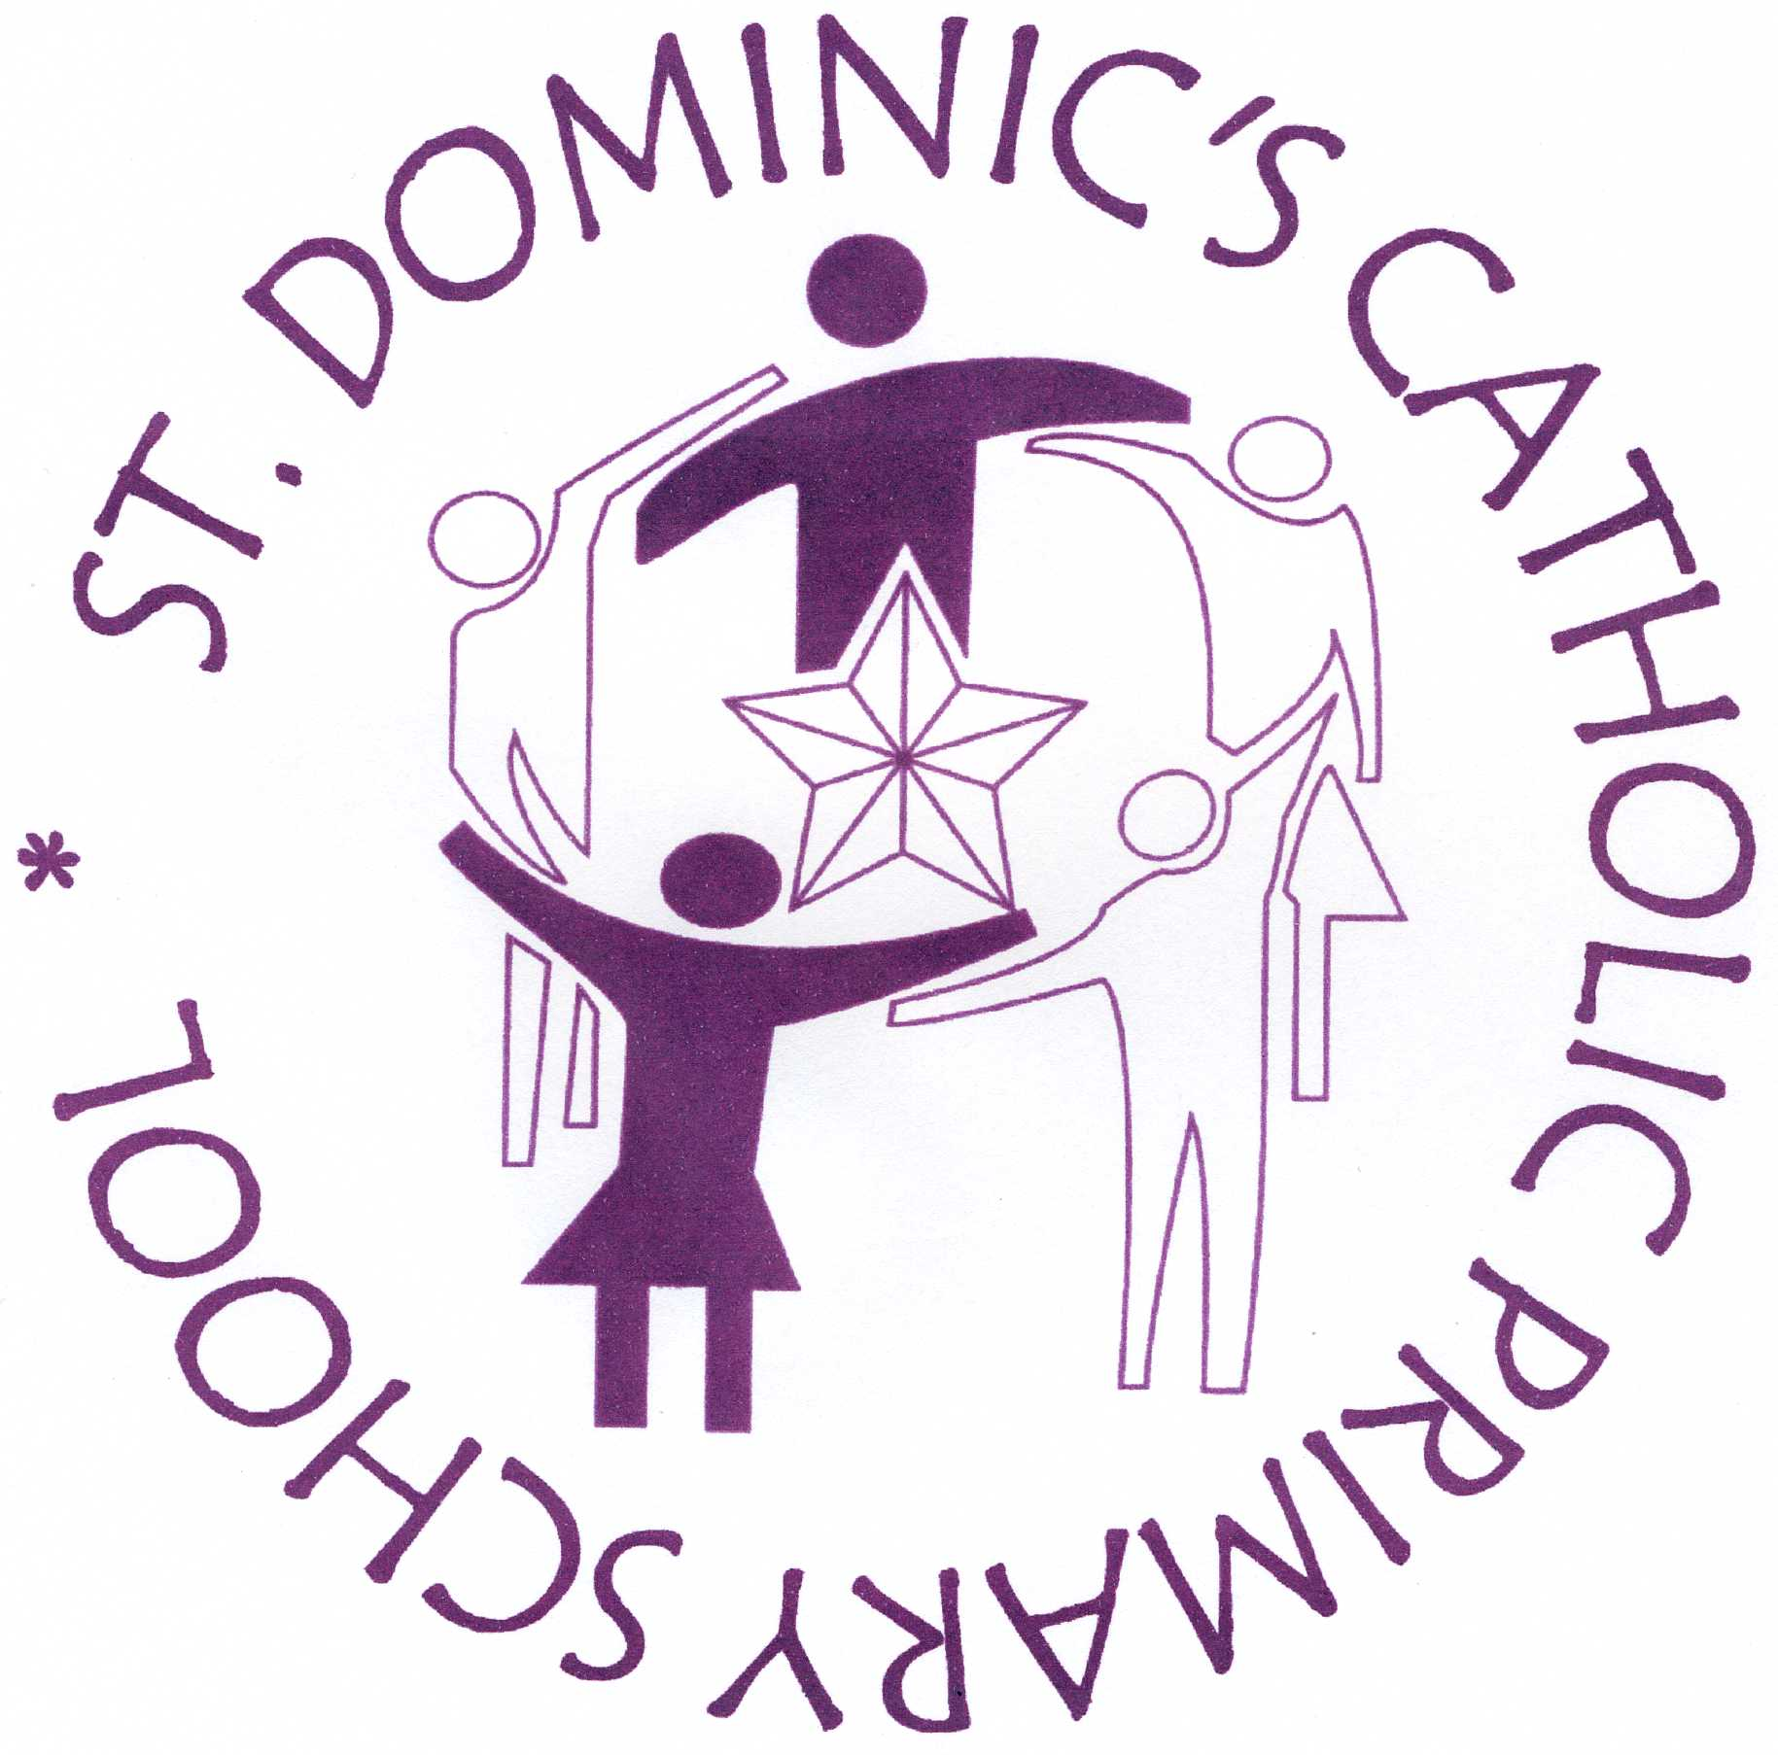

Archdiocese of Westminster
ST. DOMINIC’S CATHOLIC PRIMARY SCHOOL
Ballance Road, Hackney, London, E9 5SR.
e-mail: admin@stdominics.hackney.sch.uk

Head Teacher: Deirdre Finan Tel: 020-8985 0995

Dear Parents/Carers, 15th May 2020

Re: Possible reopening of school to more pupils in June

We know you’ve seen in the news that schools may reopen on 1 June to reception, year 1 and year 6 pupils if the government thinks it is safe then.

We’re waiting for further guidance and clarification from the government right now, which will hopefully help us create an action plan for our phased reopening. We’ll share this with you as soon as possible so you know what the school’s reopening will look like in practice.

It’s a very unsettling time for us all, but rest assured that we’re going to be doing everything we can to make sure we’re ready to receive these year groups if it’s safe for our school to reopen in the coming weeks.

However, we’re also not going to be pressuring anyone to send their children to school, since you know your children and personal situation best. The Government has advised that parents will not be fined if they make the decision for their child not return this academic year. We’ll keep you updated with all our preparations for making sure the school is as safe as possible, so you can make an informed decision.

In the meantime, the school is still open only for vulnerable pupils and the children of critical workers. We know some employers will be encouraging you to return to work, but we’re not in a position right now to extend places to other children until we receive further government guidance.

We’d like to thank you for your continuous support in helping your child learn from home. We’ll need to keep going with this for a while yet, so please do continue to do what you can and stay in touch with us about how your child is doing.

If you have any questions, please contact admin@stdominics.hackney.sch.uk

I’m sure you will agree that our teachers have been working very hard to provide your children with a creative, exciting and challenging curriculum on-line.

It is National Thank a Teacher Day on May 20th. If you would like to show your appreciation for your teachers’ dedication in the past few weeks, please visit the website ‘Thank a Teacher Day’ to find ways of expressing your gratitude!

Warm regards,

Deirdre Finan

