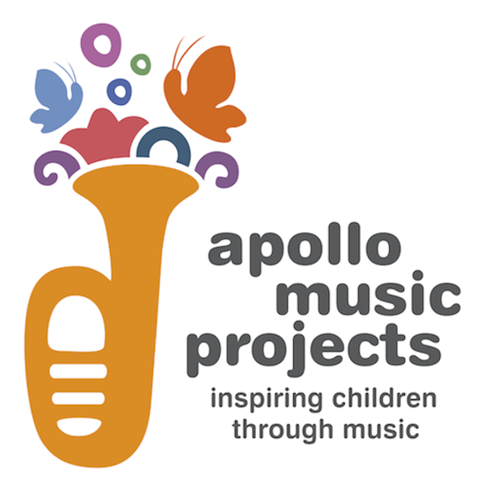

The Creative Writing Challenge

Apollo Music Projects is launching a Creative Writing Challenge to get you feeling inspired by and connected to classical music. When we play to classes in primary schools, the children always have such imaginative and poetic responses to the music and the way our musicians perform it. We decided to set musical prompts for children to write poems, stories or other pieces of writing while our musicians are unable to connect with them in the classroom.

How to take the challenge:
The challenge is open to all, but specifically designed for all children aged 4-11.

All you have to do is listen to this piece of music. It is by Schumann, and played by violinist and Apollo Associate Artist Elena Urioste, and pianist Tom Poster.

What does it make you feel? What does it make you imagine? Where does it take you – to another landscape, another time, another body?

Now, either while you’re listening to the music or immediately afterwards, create a poem, story or any other response to the music.

You don’t have to know anything about the music to take the challenge. Just think about how it makes you feel and get writing!

Send your finished work to writing@apollomusicprojects.org by Monday 29 June.
Please include your name and your age. If you have worked with Apollo musicians in school, please also include your school and year group.
It’s not a competition, but writers will receive a certificate and the musicians will select their favourite pieces of writing for display on the Apollo Music Projects website.

We can’t wait to see your creations!

