From Easter to Pentecost - Year C  Linking School, Parish and Home |  | 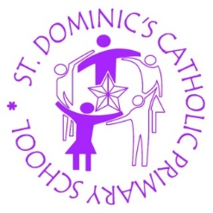 | 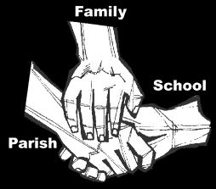
Religious Education
Key Idea: Easter to Pentecost
This resource continues learning about Easter by exploring the Season of Easter, the period from Easter Sunday to Pentecost. Belief in the resurrection is presented as one of the founding beliefs of Christians. This resource teaches from the Gospel of Luke and Acts of the Apostles, also written by Luke. It uses Luke’s technique of ‘bridge people’ to explore those who brought Christianity to England.
Attitudes and Spiritual Dispositions
Spiritual Outcomes: It is hoped that pupils will develop:  - A strengthened sense of belief in the resurrection of Jesus  - A sense of how the resurrection provides a way of living | - An appreciation of those how have gone before in faith.
Activities to try at home
You are the first educator of your child in faith. Your child’s learning in religious education will be much greater if you and the school are engaged in talking about the same ideas and beliefs.
- Easter is a time of reflection, thanksgiving and celebration. Make a point of spending time in a Church this Easter.

An idea for prayer at home
Prayer Activity
Loving God,
In loving you we are called to pass on the message of your love to others.
We thank you for all those ‘bridge people’ who have made a road for us to walk.
May we be like them; setting a path for others to follow.
Amen

